1. Execute SET GLOBAL log_output = 'TABLE';
2. Execute SET GLOBAL general_log = 'ON';
3. Take a look at the table mysql.general_log

**SET** **GLOBAL** log_output = 'TABLE';

**SET** **GLOBAL** general_log = 'ON';

**select** * **from** mysql.general_log;

**result:**

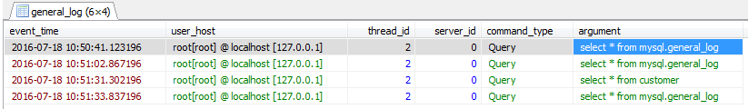

I can do it on HeidiSql, but can not on Vitalsuite.

